 ** **

**Mathematics Specialist  
YEAR 12**

**Investigation 1 – The Problem with Flies**

**Semester 1 2019**

**Time allowed:** Three weeks

Latest submission date is 11.59pm Thursday 2 May 2019

Email submission is acceptable if send to [darren.jacques@education.wa.edu.au](mailto:darren.jacques@education.wa.edu.au)

(please expect acknowledgement of email submission)

**Information: The cover page at the end of this task sheet must be attached to the front of your report prior to submission. If submitting electronically, copy the cover page and paste it into your report as the first page.**

It is expected that this assessment task be completed outside of the classroom environment. Any teacher can be asked for advice with the exception of Mr Jacques, who will be evaluating your responses to this task.

It is expected that the report be your own work and unique when compared to the submitted work of other students in this course.

You will receive a grade from the attached Performance Standards and a numerical mark for this assessment.

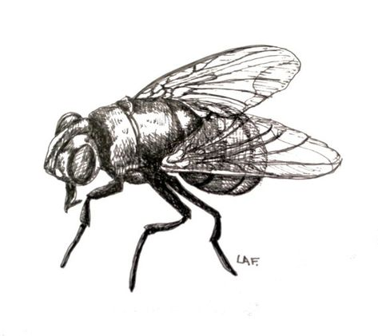**The Problem with Flies**

In this investigation you will use vectors to represent the position and velocity of two flies in space.

Consider two flies, A and B, set up the following:

* Fly A has initial position $(a, b, c)$ and has velocity vector $[d, e,f]$.
* Fly B has initial position $(g, h, l)$ and has velocity vector $[m, n, p]$.

Investigate the location of the flies, the time it will take the flies to reach a person or people at your choice of specified location(s), the shortest distance the flies are apart and when this occurs.

In addition, you need to determine the best position for the spray nozzle of an insect repellant to enable you to hit both flies with one spray.

**Part 1**

For some (sensibly) chosen values of $a, …, h, l, m, n, p)$ find the parametric equations for the position of each fly at time *t*, where *t* is the time in seconds, using *centimetres* for the distance.

How long does it take each fly to reach a person (or two people) at a point of your choice?

**Part 2**

If at time *t*, fly A is at position P and fly B is at position Q, find the time when the flies are closest to each other and their distance apart at this instant.

**Part 3**

Now investigate the best location for you to be holding the insect repellant to hit both flies with just one spray. The sprayed repellent may be represented by a line in 3D. Designate a position and velocity of sprayed insect repellant so that both flies will be within its range.

Modify your model if possible to consider the insect spray as a plane in 3D or a 3D shape.

**Part 4**

Analyse and interpret your results, including consideration of the reasonableness and limitations of the results.

**Complete a report for the mathematical investigation**

*This investigation will be completed entirely at home and must be your own work. If work is plagiarised or copied a result of zero will be awarded for the investigation.*

*The investigation report should be a maximum of 10 single-sided A4 pages if written, or the equivalent in multimodal form.*

The report may take a variety of forms, but would usually include the following:

* an outline of the problem and context
* the method required to find a solution, in terms of the mathematical model or strategy used
* the application of the mathematical model or strategy, including
  + relevant data and/or information
  + mathematical calculations and results, using appropriate representations
  + the analysis and interpretation of results, including consideration of the reasonableness and limitations of the results
* the results and conclusions in the context of the problem.

A bibliography and appendices, as appropriate, may be used.

The format of an investigation report may be written or multimodal.

Conclusions, interpretations and/or arguments that are required for the assessment must be presented in the report, and not in an appendix. Appendices are used only to support the report, and do not form part of the assessment decision.



**Mathematics Specialist  
YEAR 12**

**Investigation 1 – The Problem with Flies**

**Assessment Submission Form**

|  |  |
| --- | --- |
| **Student Name** |  |
| **Teacher** |  |
| **Date Submitted** |  |
| **Office use only**  **Date Received** |  |
| **Office use only**  **Grade/Mark** |  |

**A SIGNED COPY OF THIS FORM MUST ACCOMPANY ALL SUBMISSIONS FOR ASSESSMENT.**

**STUDENTS SHOULD KEEP A COPY OF ALL WORK SUBMITTED.**

**Note:** There are penalties for the late submission of assessments and for Plagiarism. For further information please see the Senior School Assessment Policy.

**Plagiarism** isthe unacknowledged inclusion of another person’s writings or ideas or works, in any formally presented work (including essays, examinations, projects, reports or presentations).

**Declaration of Authorship**

I declare that all material in this assessment is my own work except where there is clear acknowledgement and appropriate reference to the work of others.

**Signed……………………………………………….** **Date** ……………………………………………

**Note:** For electronic submission, a typed name instead of a signature is acceptable.